|  |  |
| --- | --- |
| File:COMSATS new logo.jpg - Wikimedia Commons  Lab Task 7 & 8 | **submitted by:**  **Shahzaneer Ahmed**  (Sp21-BCS-087)  **submitted to:**  **Mr. Rizwan Rashid**  **date of submission:**  **December 19th, 2021** |

Strings

# Question-1

*//Write a program that checks whether a string is a palindrome. A string is a palindrome if it  
// reads the same forward and backward. The words “mom,” “dad,” and “noon,” for instance,  
// are all palindromes. Sample run:  
// Enter a string: noon  
// noon is a palindrome  
// Enter a string: moon  
// moon is not a palindrome  
  
import java.util.Scanner*;  
*public class Exercise1* {  
 *public static void* main(*String*[] *args*) {  
 *Scanner* input = *new* Scanner(*System*.in);  
 *System*.out.println("Enter a string to check if it is palindrome or not :");  
 *String* str1 = input.next();  
 *String* str2="";  
  
 *for* (*int* i = str1.length()-1; i >= 0; i--){  
 str2 += str1.charAt(i);  
*// System.out.println(str2); //for back tracing what is really going on !* }  
  
 *if* (str1.equals(str2)) *System*.out.printf("%s is a palindrome !\n",str1);  
 *else System*.out.printf("%s is not a palindrome !\n",str1);  
  
 }  
  
}

# Output

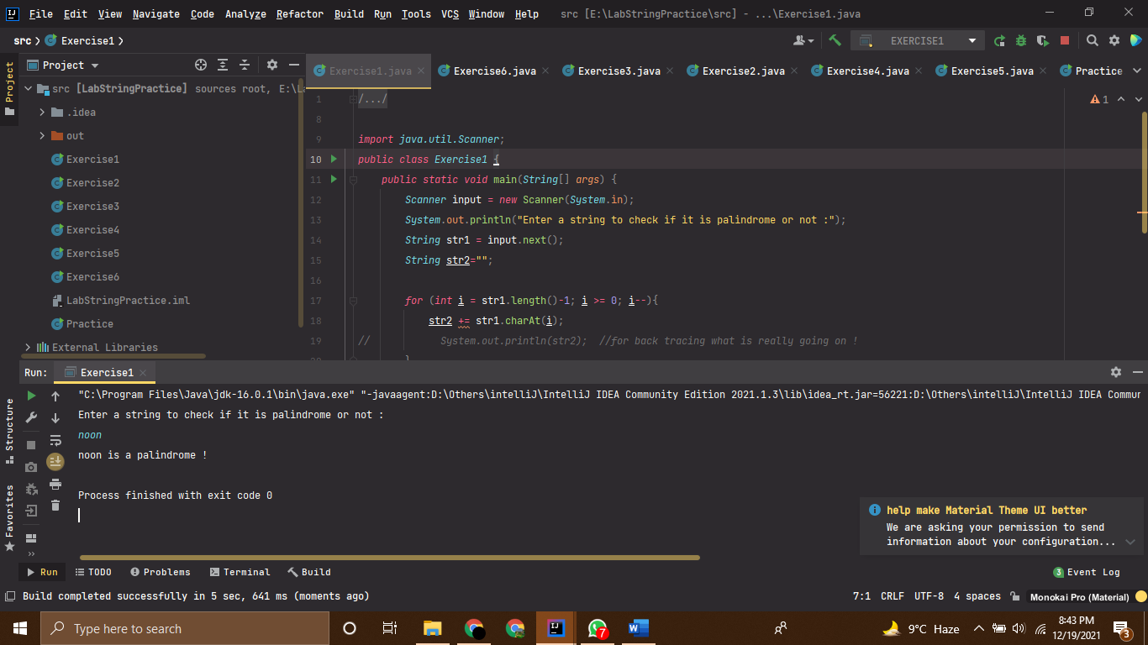

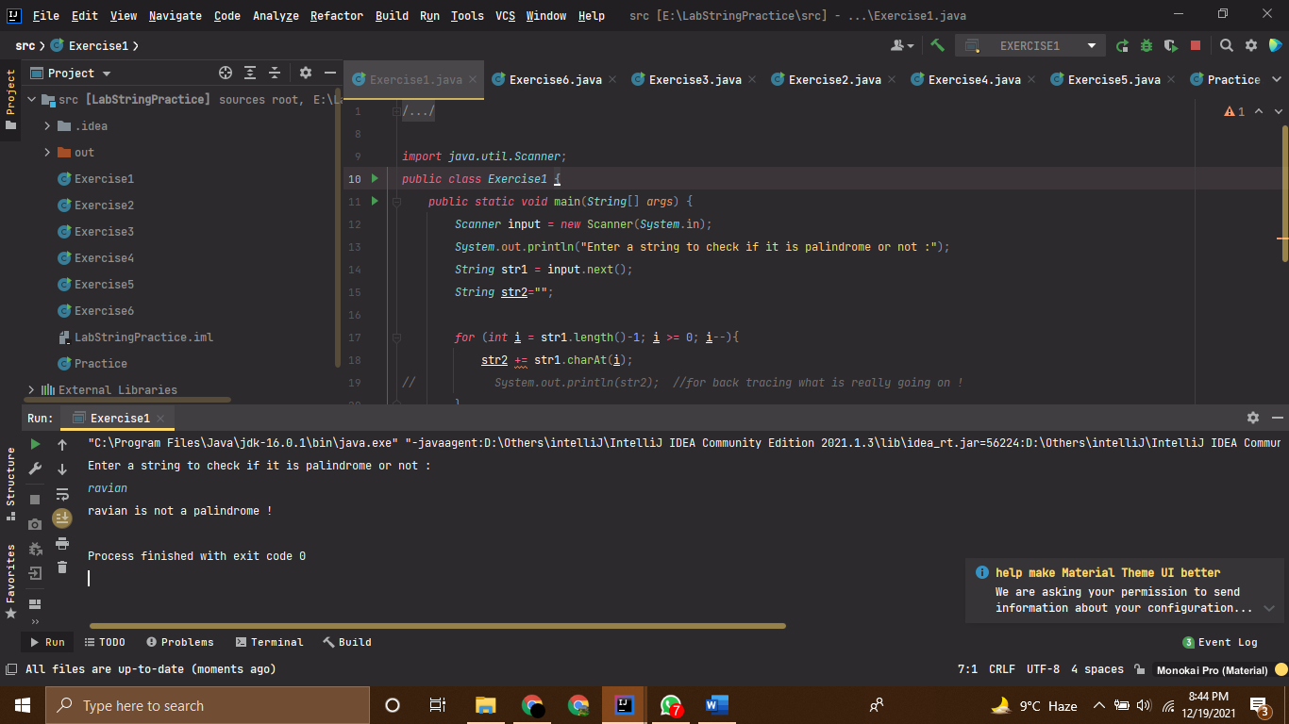

# Question-2

*//Given a string consisting of exactly two words separated by a space. Print a new string with  
// the first and second word positions swapped (the second word is printed first).  
// This task should not use loops and if.  
// Sample Run:  
// Input: Hello, world!  
// Correct Answer: world! Hello,  
  
import java.util.Scanner*;  
*public class Exercise2* {  
 *public static void* main(*String*[] *args*) {  
 *Scanner* input = *new* Scanner(*System*.in);  
 *System*.out.println("Enter a String consisting of two words separated by a space :");  
 *String* str1 = input.next(); *//here we have implemented the concept of buffer memory; next k case main white  
 // spaces se terminate houti hai string.  
 String* str2 = input.next();  
  
 *String* str3 = str2 +" "+ str1;  
 *System*.out.println(str3);  
 }  
}

# Output

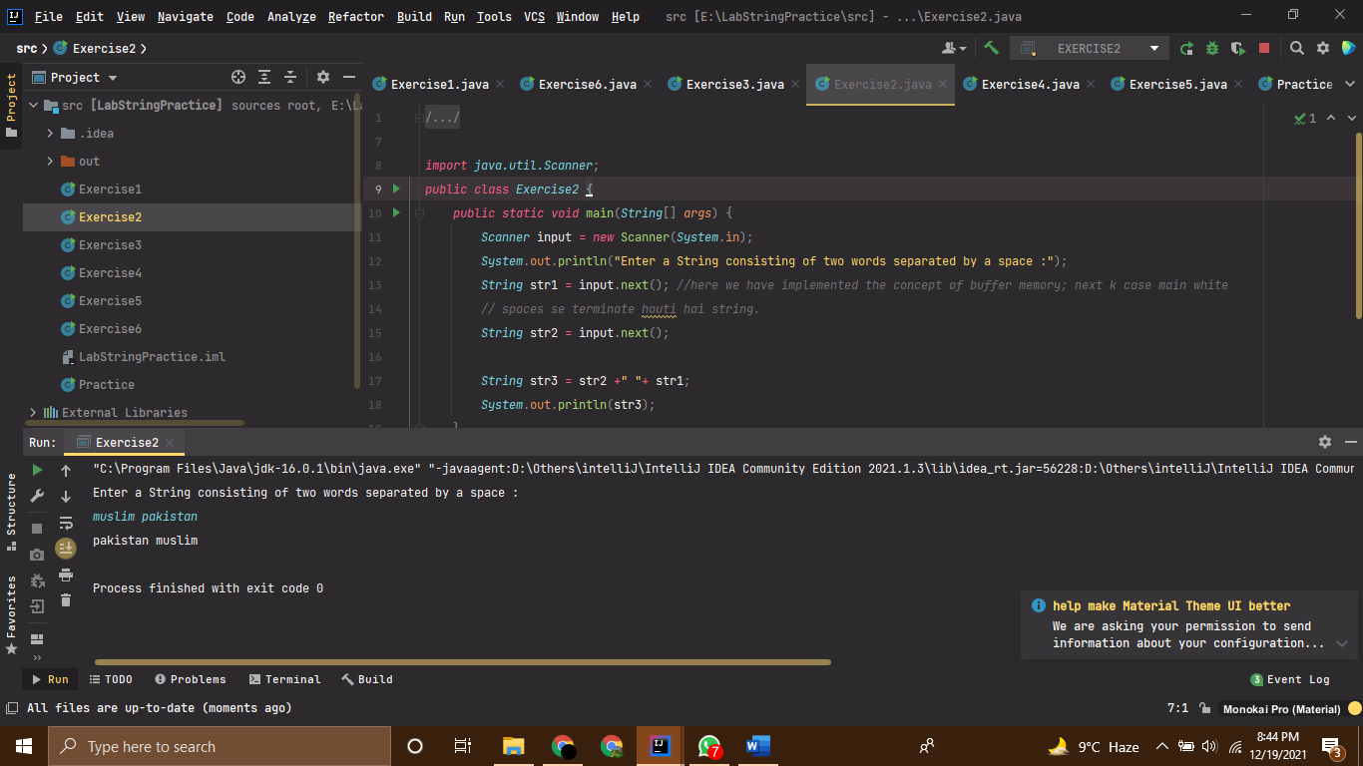

# Question-3

*//Given a string that may or may not contain a letter of interest. Print the index location of the  
// first and last appearance of f. If the letter f occurs only once, then output its index. If the  
// letter f does not occur, then do not print anything.  
// Input: office  
// Correct Answer: 1 2  
  
import java.util.Scanner*;  
*public class Exercise3* {  
 *public static void* main(*String*[] *args*) {  
 *Scanner* input = *new* Scanner(*System*.in);  
 *System*.out.println("Enter a String :");  
 *String* str1 = input.next();  
 *int* counter = 0;  
 *if* (str1.contains("f")){  
 *int* indexOfF = str1.indexOf('f');  
 *int* lastIndexOfF = str1.lastIndexOf('f');  
  
 *if* (indexOfF == lastIndexOfF) *System*.out.println(indexOfF);  
 *else* {  
 *System*.out.print(indexOfF + " ");  
 *System*.out.print(lastIndexOfF);  
 }  
 }  
 *else System*.out.print("");;  
  
  
 }  
  
  
 }

# Output

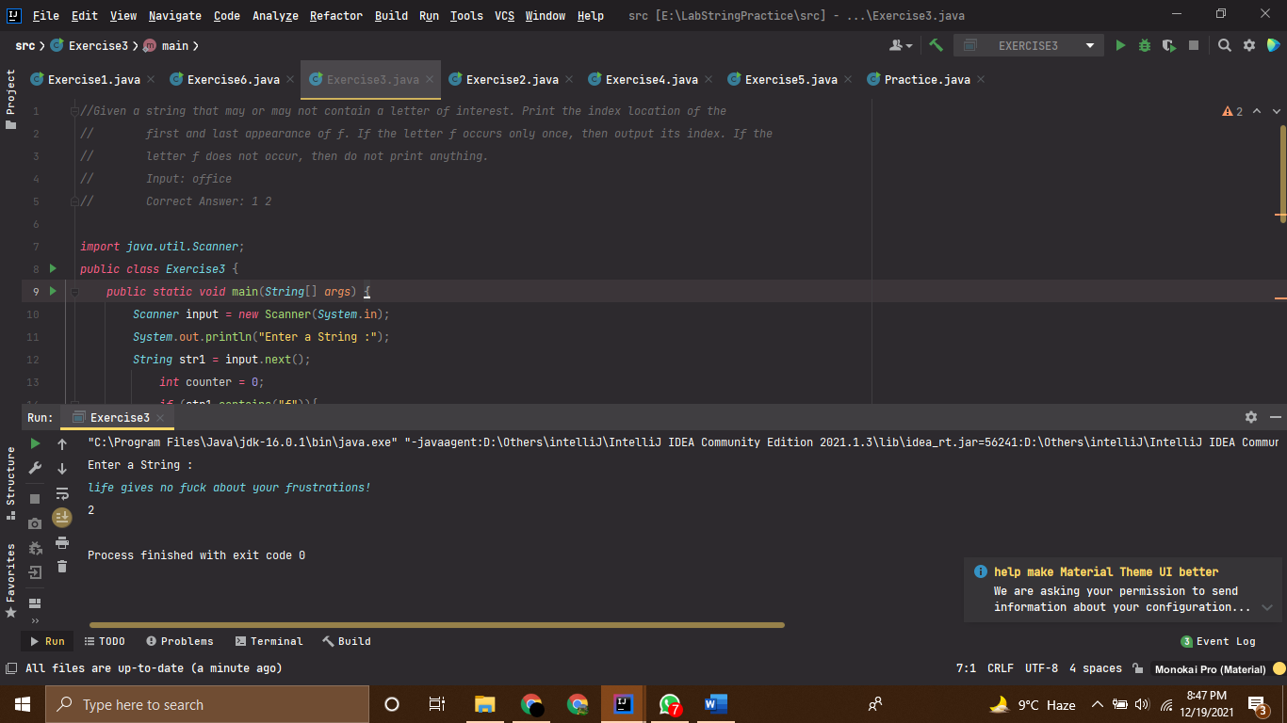

# Question-4

*//Given a string in which the letter h occurs at least twice. Remove from that string the first and  
// the last occurrence of the letter h, as well as all the characters between them.  
// Sample Run:  
// Input: In the hole in the ground there lived a hobbit  
// Correct Answer: In tobbit  
  
  
public class Exercise4* {  
 *public static void* main(*String*[] *args*) {  
 *String* str1 = "In the hole in the ground there lived a hobbit";  
 *String* strPart1 = str1.substring(0,(str1.indexOf('h')));  
 *String* strPart2 = str1.substring((str1.lastIndexOf('h')+1),(str1.length()));  
  
 *String* strFixed = strPart1+strPart2;  
 *System*.out.println(strFixed);  
  
  
  
 }  
}

# Output

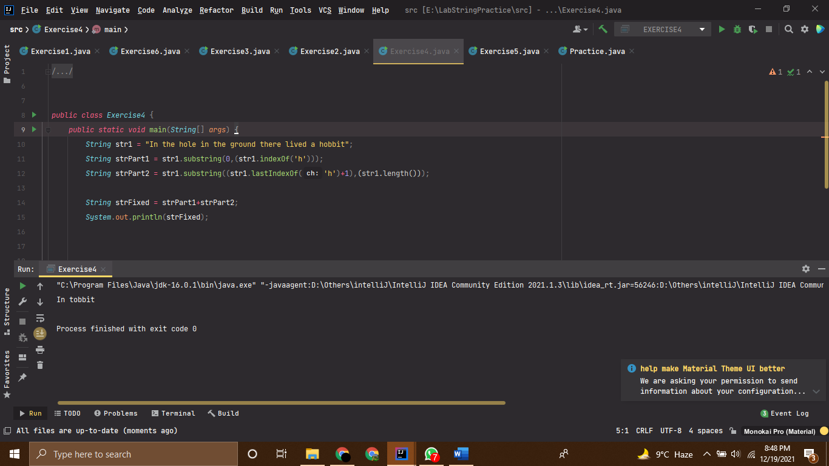

# Question-5

*//You are given a string.  
// In the first line, print the third character of this string.  
// In the second line, print the second to last character of this string.  
// In the third line, print the first five characters of this string.  
// In the fourth line, print all but the last two characters of this string.  
// In the fifth line, print all the characters of this string with even indices (remember indexing  
// starts at 0, so the characters are displayed starting with the first).  
// In the sixth line, print all the characters of this string with odd indices (i.e. starting with the  
// second character in the string).  
// In the seventh line, print all the characters of the string in reverse order.  
// In the eighth line, print every second character of the string in reverse order, starting from the  
// last one.  
// In the ninth line, print the length of the given string.  
// Sample Run:  
// Input: Hello  
// l  
// l  
// Hello  
// Hel  
// Hlo  
// el  
// olleH  
// olH  
// 5  
  
import java.util.Scanner*;  
*public class Exercise5* {  
 *public static void* main(*String*[] *args*) {  
 *Scanner* input = *new* Scanner(*System*.in);  
 *System*.out.println("Enter any String :");  
 *String* str = input.next();  
 *System*.out.println(str.charAt(2)); *//first line -- Third character  
  
  
 for* (*int* i = str.length()-2;i<=str.length()-2;i++) *System*.out.print(str.charAt(i));  
 *System*.out.println(); *//In the second line, print the second to last character of this string.  
  
  
 for* (*int* i = 0; i<5;i++){  
 *System*.out.print(str.charAt(i));  
 }  
 *System*.out.println();  
 *// In the third line, print the first five characters of this string.  
  
 for* (*int* i = 0 ; i<=str.length()-3; i++){  
 *System*.out.print(str.charAt(i));  
 }  
 *System*.out.println();  
 *//In the fourth line, print all but the last two characters of this string.  
  
  
 for* (*int* i = 0; i<str.length();i++){  
 *if* (i%2==0) *System*.out.print(str.charAt(i));  
 }  
 *System*.out.println(); *//In the fifth line, print all the characters of this string with even indices  
 // (remember indexing starts at 0, so the characters are displayed starting with the  
 // first).  
  
  
 for* (*int* i = 0; i<str.length();i++){  
 *if* (i%2==1) *System*.out.print(str.charAt(i));  
 }  
 *System*.out.println(); *//In the sixth line, print all the characters of this string with odd indices (i.e. starting with the  
// second character in the string).  
  
 for* (*int* i = str.length()-1;i>=0;i--){  
 *System*.out.print(str.charAt(i));  
 }  
 *System*.out.println(); *//In the seventh line, print all the characters of the string in reverse order.  
  
 for* (*int* i = str.length()-1; i>=0;i-=2){  
  
 *System*.out.print(str.charAt(i));  
 }  
 *System*.out.println(); *//In the eighth line, print every second character of the string in reverse order, starting from the  
// last one.  
  
 System*.out.println(str.length());  
 *System*.out.println(); *//In the ninth line, print the length of the given string.* }  
}

# Output

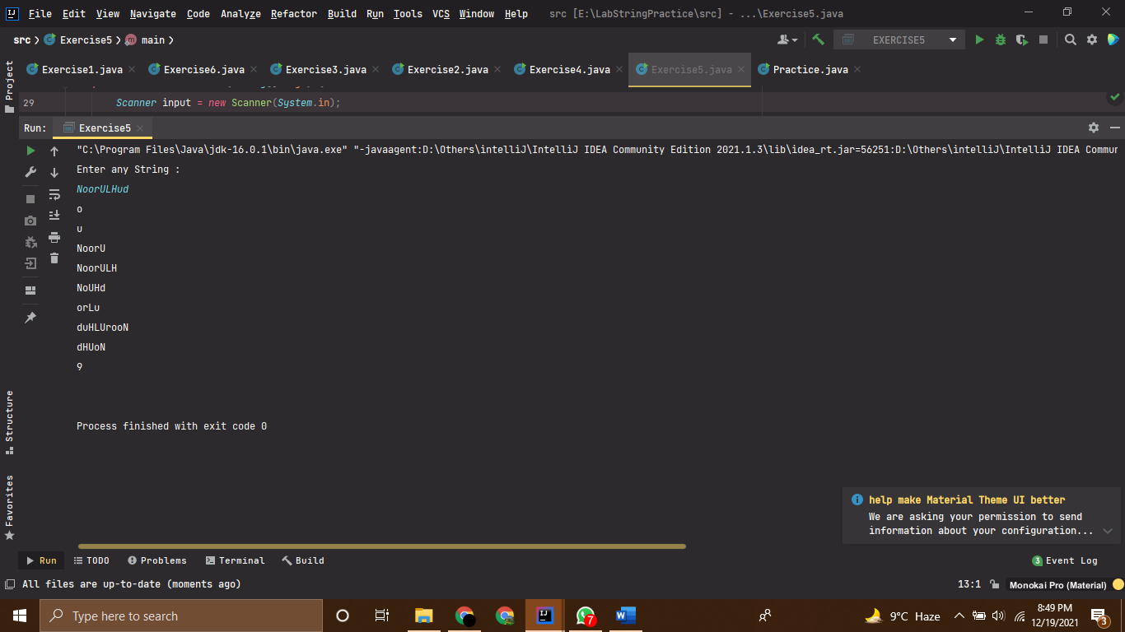

# Question-6

*//Given a string. Replace every occurrence of the letter h by the letter H, except for the first and  
// the last ones.  
// Input: In the hole in the ground there lived a hobbit  
// Correct Answer: In the Hole in tHe ground tHere lived a hobbit  
  
public class Exercise6* {  
 *public static void* main(*String*[] *args*) {  
 *String* str = "In the hole in the ground there lived a hobbit";  
 *String* str1 = str.replace('h','H');  
 *String* strFirstHalf = str.substring(0,(str.indexOf('h')+1));  
 *String* strLastHalf = str.substring(str.lastIndexOf('h'),(str.length()));  
 *String* strMiddle = str1.substring(str1.indexOf('H')+1 , (str1.lastIndexOf('H')));  
 *String* modeifiedString = strFirstHalf+strMiddle+strLastHalf;  
 *System*.out.println(modeifiedString);  
  
  
  
 }  
  
  
 }

# Output

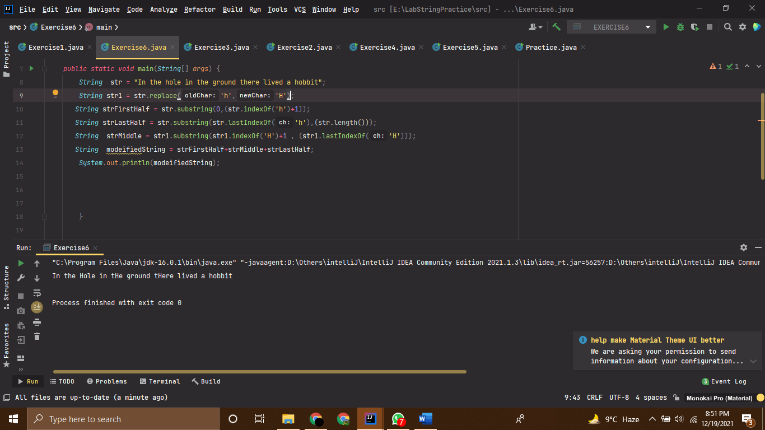

Nested Loops

# Question-1

*//------------------------------------------------------------------  
//--------------------SHAHZANEER AHMED------------------------------  
//-----------------------SP21-BCS-087-------------------------------  
//-----------------------Question 1---------------------------------  
//------------------------------------------------------------------  
  
//Write a program that reads an unspecified number of integers, determines how many  
// positive and negative values have been read, and computes the total and average of the  
// input values (not counting zeros). Your program ends with the input 0. Display the  
// average as a floating-point number. Here is a sample run:  
// Enter an integer, the input ends if it is 0: 1 2 -1 3 0  
// The number of positives is 3  
// The number of negatives is 1  
// The total is 5.0  
// The average is 1.25  
  
  
import java.util.Scanner*;  
*public class Exercise1* {  
 *public static void* main(*String*[] *args*) {  
 *Scanner* input = *new* Scanner(*System*.in);  
 *int* counter=0;  
 *int* positiveCounter=0;  
 *int* negativeCounter=0;  
 *float* sum = 0f , average;  
 *System*.out.println("Enter Integers and 0 to terminate the loop !");  
  
 *while* (*true*){  
 *int* num = input.nextInt();  
 *if* (num==0) *break*;  
 *else*{  
 counter+=1;  
 sum+=num;  
 *if*(num>0) positiveCounter+=1;  
 *else if* (num<0) negativeCounter+=1;  
  
 }  
 }  
  
 average = sum/counter;  
 *System*.out.println("The no of positive numbers are :"+positiveCounter);  
 *System*.out.println("The no of negative numbers are :"+negativeCounter);  
 *System*.out.println("The sum is "+sum);  
 *System*.out.println("The average is is "+average);  
  
 }  
 }

# Output

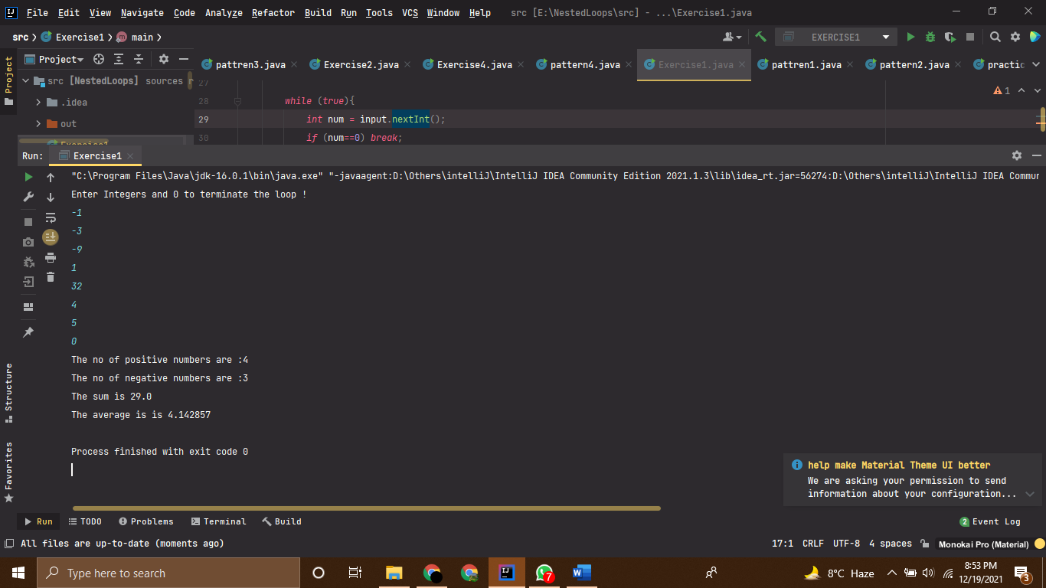

# Question-2

*//------------------------------------------------------------------  
//--------------------SHAHZANEER AHMED------------------------------  
//-----------------------SP21-BCS-087-------------------------------  
//-----------------------Question 2---------------------------------  
//------------------------------------------------------------------  
  
//Write a program that prints the characters in the ASCII character table from! To ~.  
// Display ten characters per line. Characters are separated by exactly one space.  
public class Exercise2* {  
 *public static void* main(*String*[] *args*) {  
 *int* counter = 0;  
  
 *for* (*int* i = 33; i<=126; i++){  
*// the ascii value of ! is 33 and ~ is 126.  
// all the other values/Ascii characters are in between these ascii characters* counter+=1;  
  
 *if* (counter%10!=0) *System*.out.print((*char*)i+" ");  
  
 *else if* (counter%10==0) *System*.out.println((*char*)i);  
 }  
  
 }  
}

# Output

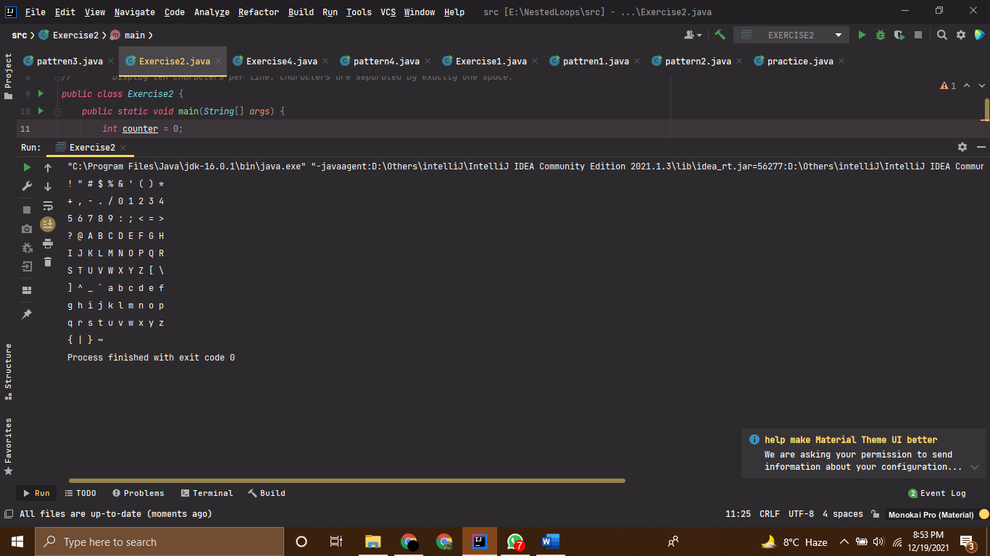

# Question-3

## Pattern-1

*public class pattren1* {  
 *public static void* main(*String*[] *args*) {  
 *for* (*int* i = 1; i<=6;i++){  
 *for* (*int* j = 1; j<=i;j++){  
 *System*.out.print(j+" ");  
 }  
 *System*.out.println();  
 }  
 }  
}

## Pattern-2

*public class pattern2* {  
 *public static void* main(*String*...*args*) {  
  
 *for*(*int* i=6; i>=1; i--){  
 *for* (*int* j=1; j<=i; j++){  
 *System*.out.print(j+" ");  
 }  
 *System*.out.println();  
 }  
 }  
}

## Pattern-3

*public class pattren3* {  
 *public static void* main(*String*[] *args*) {  
 *int* n = 6;  
 *for* (*int* i = 1 ; i<=n;i++){  
  
 *for* (*int* j = n-i; j>=1; j--){  
 *System*.out.print(" ");  
 }  
 *for* (*int* k = i; k>=1;k--){  
 *System*.out.printf("%1d",k);  
 }  
 *System*.out.println();  
 }  
 }  
}

## Pattern-4

*public class pattern4* {  
 *public static void* main(*String*[] *args*) {  
 *for* (*int* rows = 6; rows>=1; rows--){  
 *int* n = 6;  
 *for* (*int* spaces = n-rows; spaces>=1; spaces--){  
 *System*.out.print(" ");  
 }  
  
 *for* (*int* columns = 1; columns<=rows;columns++){  
 *System*.out.print(columns);  
 }  
 *System*.out.println();  
 }  
  
 }  
}

# Output

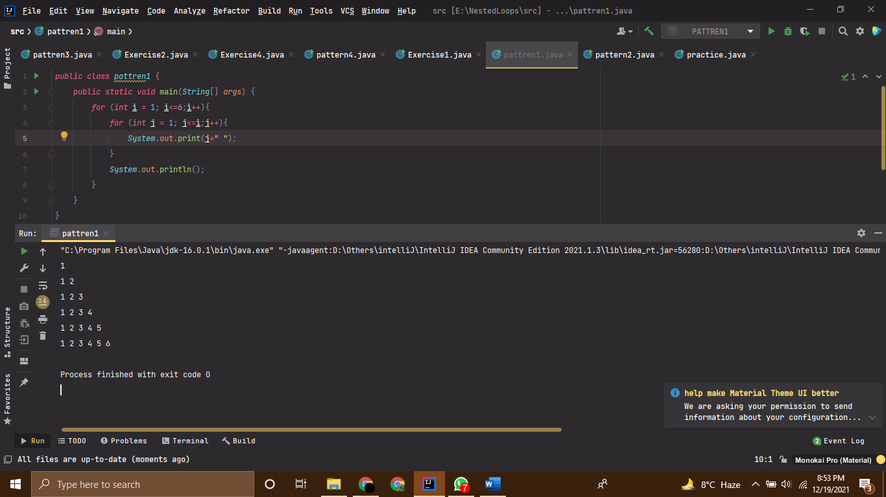

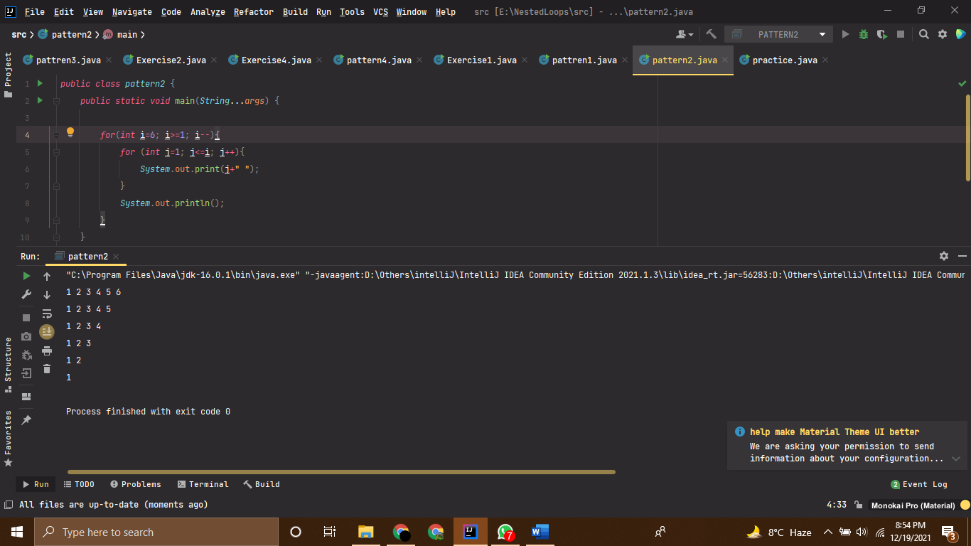

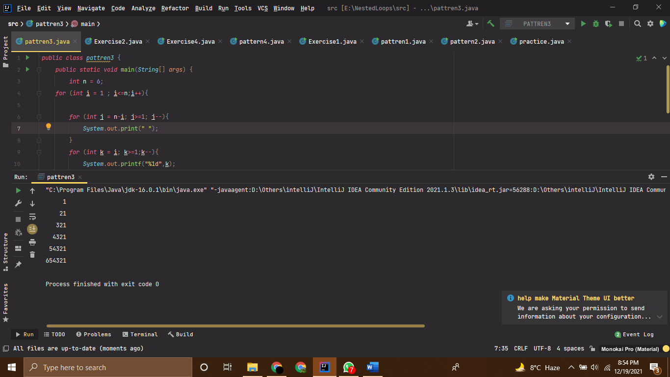

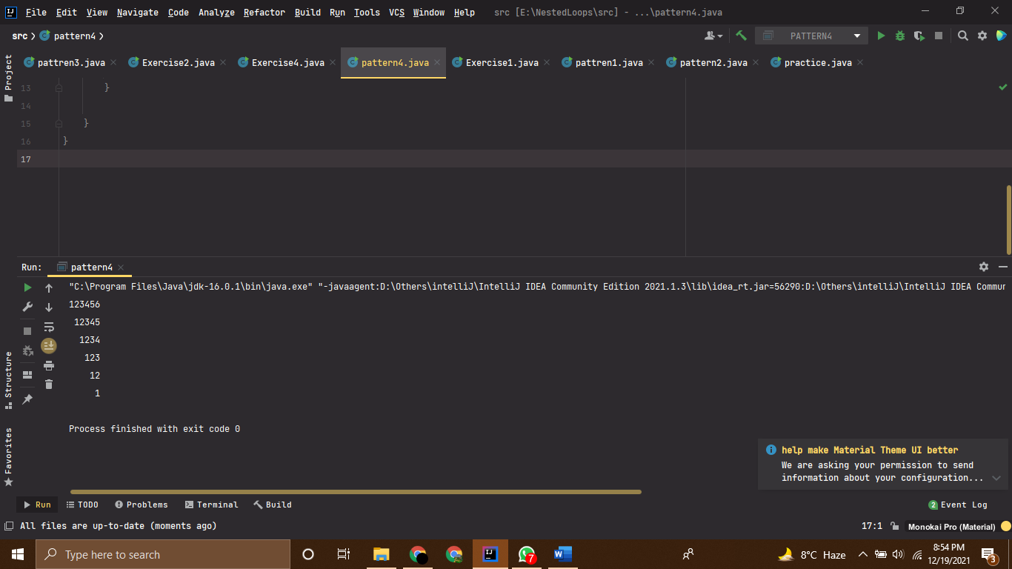

# Question-4

*//------------------------------------------------------------------  
//--------------------SHAHZANEER AHMED------------------------------  
//-----------------------SP21-BCS-087-------------------------------  
//-----------------------Question 4---------------------------------  
//------------------------------------------------------------------  
  
//Write a program that display a multiplication table as shown  
public class Exercise4* {  
 *public static void* main(*String*[] *args*) {  
  
 *System*.out.print(" "); *//spacing before the first line  
 for*(*int* i = 1; i<=9;i++ ) {  
 *System*.out.printf("%3d ",i);  
*// printing the first row* }  
 *System*.out.println();  
 *System*.out.println("------------------------------------------");  
*// printing the pattern  
  
 for*(*int* i = 1 ;i<=9;i++) {  
  
 *System*.out.printf("%4d |",i);  
*// printing the left most column  
 for*(*int* j=1;j<=9;j++) {  
 *System*.out.printf("%4d",i*j);  
*// printing the tables* }  
 *System*.out.println();  
*// printing the new line .* }  
  
  
 }  
}

# Output

